Computer Graphics Assignment 1

# Organising the Scene

I started by putting together a scene with interesting textures and shadows while still trying to manage the difficulty of recreating it I blender and PBRT.

I started with a plant, cereal box, poster and the PBRT book, with all but the plant being recreated in blender, though I had trouble recreating this due to measurements and floor textures. (Figure 1)

I then moved on to try create the scene roughly taking better measurements and using an (off) lamp to cast a better shadow in the scene, but again I wasn’t precise enough, additionally realising that the shine of the PBRT book was also causing issues. (Figure 2)

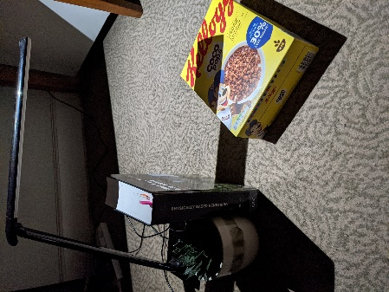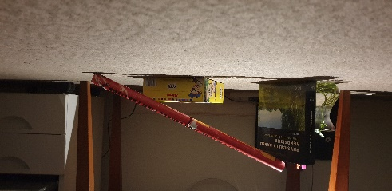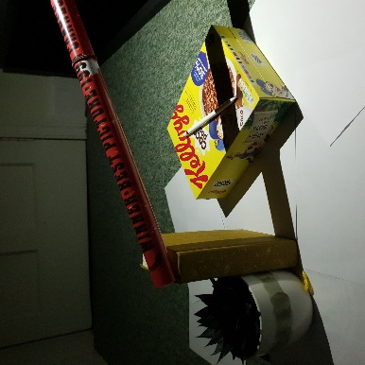Finally I arranged a similar scene again, this time with a white floor, a non reflective book replacing the PBRT book (finally remembering the pen!) and returning to the poster. (Figure 3)

Figure 2: Second Attempt

Figure : First Attempt

Figure 3: Final Attempt

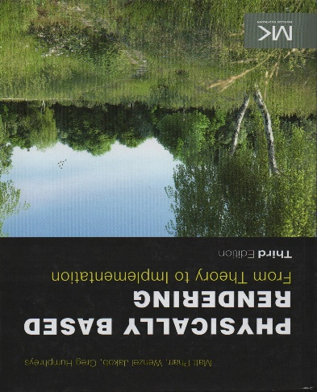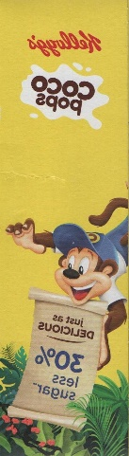I then scanned in all the textures needed (and possible, the poster was not a texture I could scan in), figures 5-8 show these textures.

Figure 6: PBRT Book

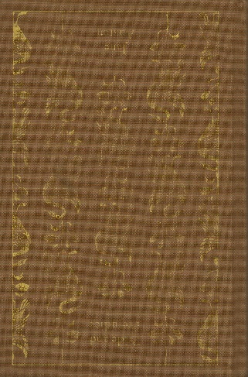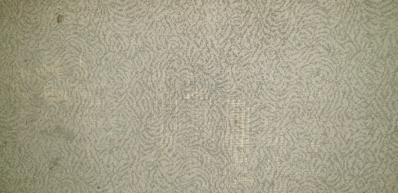

Figure 7: Alternate Book

Figure 8: Floor Texture

Figure 5: Cereal Box

# Modelling

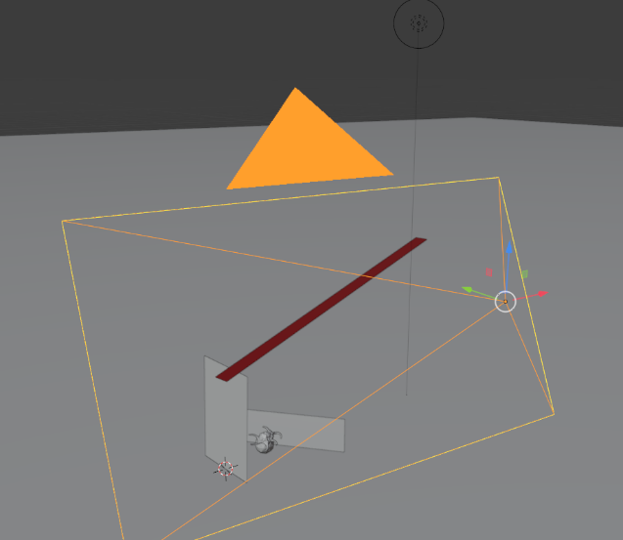Even with more precise measurements, I found the modelling process to be an iterative one.

I started by modelling the environment using the measurements I had taken, this produced a render fairly close to the photo, but with a few inconsistencies.

I would go back to the model and change angles and positions, re-rendering and comparing each time until I ended up with a result I was satisfied with.

I chose to add a mirrored ico-Sphere and a ply shell to my scene as my virtual objects

Figure 9 shows the final blender scene.

Figure 9: Blender Scene

# Exporting and Rendering

After exporting I found my resulting render to be pitch black, after some searching, I found that the point light had its RGB intensity set to all 0s, changing this to all 10s produced a clear result that wasn’t too bright and matched the scene well enough.

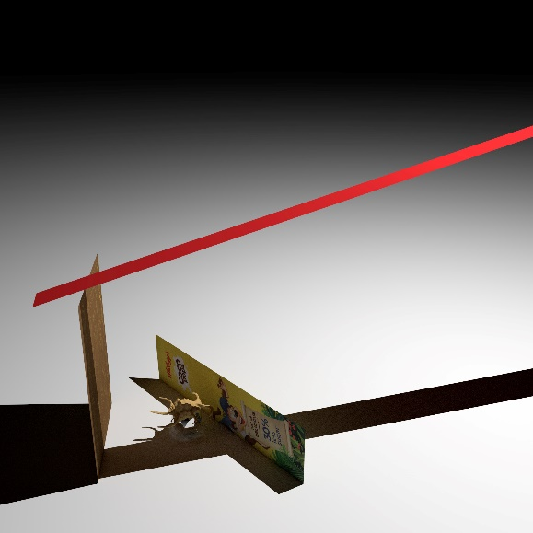Additionally, the field of view parameter of the camera was incorrect, I solved this with trial and error, increasing and decreasing the field of view until the scene was roughly the same size in the render as in the photo. Unfortunately looking up and using the field of view of the camera I used (my phone camera) did not produce a good result, I believe this to be due to post processing and auto focusing done by the phone.

Figure 10: Final Render

Finally, it also appeared that the image was shifted down and to the left compared to both the photo and the preview in blender. Though this wasn’t an issue as the scene was in view and all I needed to do was to move the render (and scale slightly) but hand to match the photo. The overlap of items outside the scene didn’t matter as they would be cut out of the composite anyway.

Figure 10 shows the final render used in the composited image.

# Compositing

Compositing the rendered and real image consisted of reducing the opacity of the render in order to scale and translate it to match the original. I then cut out the majority of the rendered image leaving only areas affected by the addition of the virtual objects.

The next step was the adjust the levels of the rendered image to match the original photo, I ended up increasing the green levels and reducing the value over all to match the lighting more closely.

Finally, I used the blur tool to clean up rendering noise in the virtual shadows.

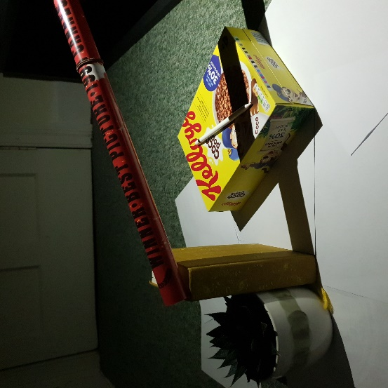Below (Figure 11, is the resulting composited image next to the original)

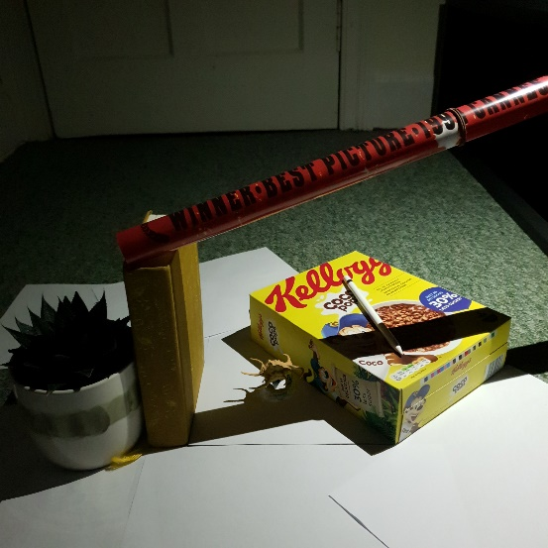

Figure 11: Comparison of composited and original image.

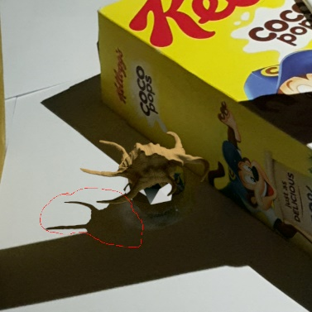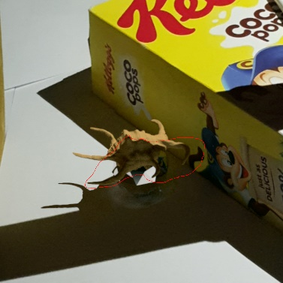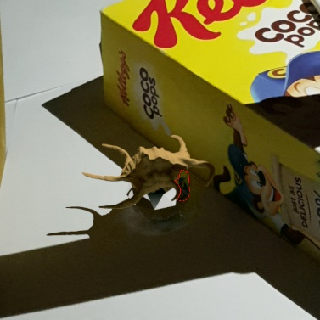Below are more figures showing details of the virtual image:

Figure 12: Reflection of cereal box on the virtual ico-sphere

Figure 14: Shadow of virtual shell on the floor surface

Figure 13: Shadow of poster on the virtual shell

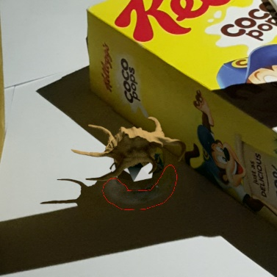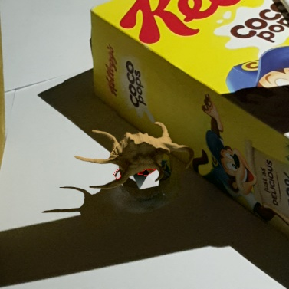

Figure 16: caustic effect of ico-sphere on the floor surface

Figure 15: reflection of virtual shell on the virtual ico-sphere

# Bibliography

Shell PLY and texture: <https://www.artec3d.com/3d-models/sea-shell>

Photo editing software (Gimp): <https://www.gimp.org/>

3D modelling software (Blender): <https://www.blender.org/>

Blender to PBRT exporter: <https://github.com/stig-atle/io_scene_pbrt>